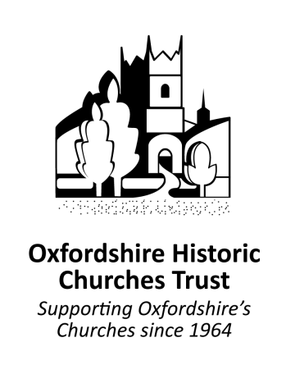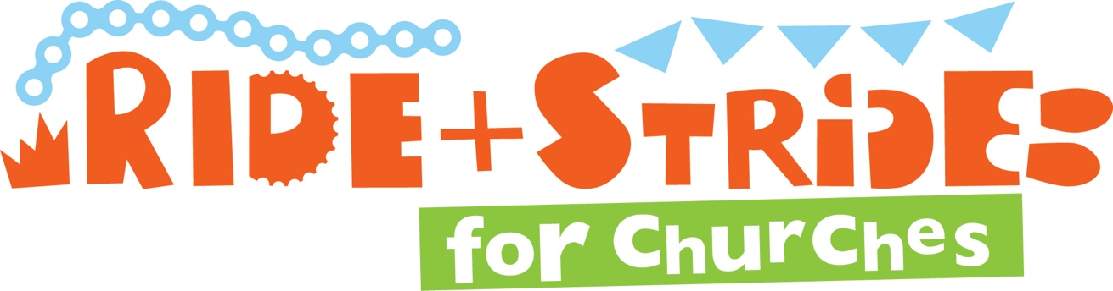



Registered Charity No 1168567

Registered Charity No 1168567

**This Way**