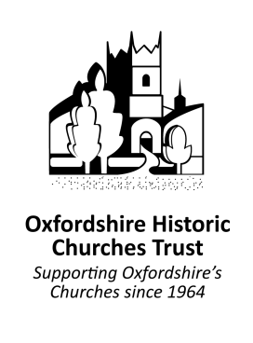
If you would like to be put in touch with your local church organiser, please complete and send the form below:

Name
Address
Postcode
Telephone Number
e-mail Address
How are you planning to take part – cycle, walk, horse ride, welcome people in church, other
Church to receive 50% of your sponsorship money (before GiftAid) or 100% to OHCT

