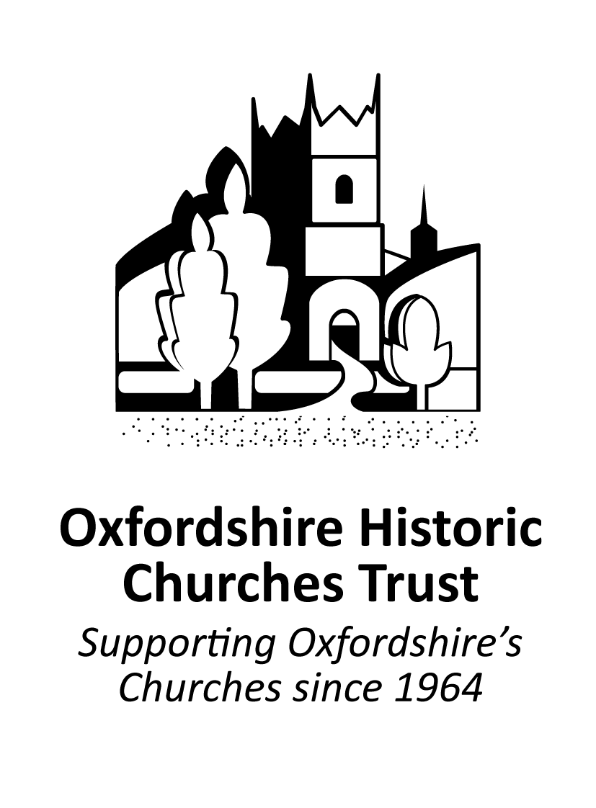



39th Sponsored Ride+Stride

Saturday 13th September 2025 10.00am - 6.00pm

Brief for Participants

Thank you for taking part in R+S, your support is greatly appreciated. Since the Trust was foundedgrants totalling several million pounds have been made to churches in Oxfordshire. A significant proportion of this money has been raised by the annual Ride+Stride, last year raising £89,000.

Ride+Stride participants can nominate to raise funds for an Oxfordshire church or chapel to receive 50% of their sponsorship (excluding Gift Aid) or give 100% of their sponsorship to the work of OHCT.

This Briefing Note details all you need to know -

1. about taking part
2. the collection and paying in the sponsor money.

For any queries, please contact your local Ride+Stride Area Coordinator, or the County Organiser, [rideandstrideoxon@ohct.org.uk](mailto:rideandstrideoxon@ohct.org.uk)

As Oxfordshire’s Ride+Stride is part of a national event taking place on the same day, St/Riders are welcome to cross county boundaries to visit churches and chapels or take part in another part of the country or even abroad.

If required, you can take part on any other day although it is probable that only a limited number the churches may be open and, in all instance’s, participants will need to sign their own sponsor forms.

Taking part is very simple!

* Sign up online - <https://ohct.org.uk/ride-and-stride/take-part/> - this form will also enable you to choose which church to nominate if you wish to do so.
* Ideally sign up for online fund raising [ohct.org.uk/online-giving](http://ohct.org.uk/online-giving) - it makes getting the word out that you’re taking part easy and saves the hassle of chasing people up after the event to get the money.
* A list of churches in Oxfordshire (by location) is available on our website – and is updated regularly.
* Use our route planner – <https://ohct.org.uk/ride-and-stride/take-part/route-planner/>
* Almost all our R+S paperwork can be downloaded from our website
* Support is always available to answer your queries – [rideandstrideoxon@ohct.org.uk](mailto:rideandstrideoxon@ohct.org.uk)

Other ‘top tips’ -

Advertise Ride+Stride locally :

* Good publicity is essential! If you have participated in the past 2 years we will send you a small R+S mailing. Please put the poster mailed to you in a good location – maybe the local pub, coffee shop, bicycle retailer or a community notice board.
* Promote it in your church or community newsletter or magazine. The Ride+Stride logo can be downloaded from the website, or you can use the template on our website – just customise it as required - <https://ohct.org.uk/wp-content/uploads/2022/06/Copy-for-local_village-newsletter-or-magazine-1.pdf>
* Make contact with any local or youth organisations who may be interested in taking part. Or recruit a few friends!
* If you plan to take part in a noteworthy way, please contact the County Organiser well before the event at [rideandstrideoxon@ohct.org.uk](mailto:rideandstride.press@ohct.org.uk) so we can support getting good publicity.

Encourage people to take part:

* Please spread the word! Encourage anyone interested to sign up online via our website. All available materials can be downloaded from our website.
* Remember some employers offer matched funding.
* St/Riders, Welcomers and Sponsors do not have to be members of a church.
* Please encourage sponsors who are UK taxpayers to Gift Aid their donation – a full name (individual), home address with postcode and tick in the GiftAid box are needed for each sponsor. Last year Gift Aid raised over £11,000.
* Please remember to take photographs during the day – the more unusual, fun or a bit quirky the better and e-mail them to us at [rideandstrideoxon@ohct.org.uk](mailto:rideandstrideoxon@ohct.org.uk) or upload via our website.

Collect the money:

* Please collect money from your sponsors as soon as possible after your St/Ride. If your nominated church has a Church Coordinator, please pass it to them, ideally by 31 October. Sponsor money raised on-line through GoodHub our fund-raising platform partner, will be paid directly to OHCT. The 50% share of your sponsorship is paid into the bank account of your nominated church (or designate it 100% for OHCT).

Sending the sponsorship money direct to OHCT if you prefer:

* Full instructions are on our OHCT Paying In Form. Please remember to send the top part of this Form to us within 2 days with all the sponsor forms. Without the OHCT Paying In Form, the 50% share of the sponsorship will not be paid to a nominated church so that money will in effect become a donation to OHCT. If you were not mailed a copy of the OHCT Paying In Form please email [rideandstrideoxon@ohct.org.uk](mailto:rideandstrideoxon@ohct.org.uk) for a copy. YOU MUST USE THE 2025 FORM – if mislaid PLEASE contact OHCT for a replacement. THIS FORM IS NOT AVAILABLE ON OUR WEBSITE. Please do not post cash to us – sadly this has disappeared in the post on several occasions.
* Please make sure that:

1. each sponsor form has your name and full address including the postcode, telephone number and preferably an e-mail address for any queries.
2. all Gift Aid entries have the sponsor’s initial and surname (one person only, not Smith family, R & D Smith, Richard or Grandma), house name or number and postcode.

All this information is required for the Gift Aid claim.

* Preferably pay in cash as cash rather than a cheque to cover it as some additional ‘Gift Aid’ can be claimed on some cash deposits.Please list all the cheques on the Paying In Form and ensure that donations can be identified as being paid in by cash or cheque.
* Cheques and charity vouchers should be made payable to OHCT Ride and Stride. Please send charity vouchers promptly as they go out of date after 6 months.
* Please do not include money raised online through GoodHub on the Paying In Form or Sponsor Form.
* Please keep a record of the amount and date paid in and the Paying In Form number (top right-hand corner) in case of queries please email [rideandstrideoxon@ohct.org.uk](mailto:rideandstrideoxon@ohct.org.uk) or call 07831 690524.
* 50% of the money raised for a nominated church (excluding Gift Aid) is returned to it by OHCT. If we have an e-mail address for you, you will receive a thank you message showing the amount being paid and date.
* The half share of the sponsor money retained by the OHCT will be used for making grants to churches and chapels built in Oxfordshire before 1950 towards major restorations or re-ordering schemes. The costs of running Ride+Stride are covered by the Gift Aid tax rebate.

In the unlikely event of any accidents occurring during your Ride+Stride, please notify the County Organiser.

*If your church or chapel is to undertake a restoration project or re-ordering scheme, please encourage your Church Council to contact the Trust about applying for a Grant – more information can be found on the OHCT website.*

Ride+Stride County Organiser: Hilary CakebreadHall

Tel: 07831 690524 Email: rideandstrideoxon@ohct.org.uk



OHCT Website Address: [www.ohct.org.uk](http://www.ohct.org.uk)